Appl. Cosmetic Sci. & Tech. 54(1): 00-00
Original, Short Communication, Material, Review ―――――――――――――

How to Write an Original Paper Using This Template
Ichiro Yamada^{1＊}, Jiro Suzuki¹, John Smith²
¹ Research and Development Department, SCCJ Corporation, 1-2-3, ○○, Minato-ku, Tokyo 000-0000, JAPAN
² ABC Department, IFSCC University, 123 Wall Street, New York, NY 00000, USA

Please write the abstract in 200‒300 words (Times New Roman, 10-point scale). The article title must be 16-point (Times New Roman, in bold). Use 12-point (Times New Roman) for author names, and 11-point (Times New Roman) for affiliations and addresses.
Please add * in superscript on the name of the corresponding author and enter their email address at the bottom of this page.
(leave one line space)
Key words: Enter 10 or more important key words extracted from the title and the abstract, and arrange the key words in the order of importance.

1. Introduction

Write the text (Introduction) from here. Use 10.5-point Times New Roman font for normal text and 11-point bold font for headings and subheadings.
For details on how to write the manuscript, please refer to the "Journal of the Society of Cosmetic Chemists of Japan Manuscript Submission Guideline".
(leave one line space)
2. Materials and Methods

From here, please write the materials and methods.
2.1. Insertion of figures and tables (capitalize the first word of a sentence)
Paste or prepare a figure or table on the upper or lower portion of an appropriate page. For the caption of a figure, write "Fig.- 0" below the figure, and for a table, write "Table-0" above the table. Then, write the title and description after the numbering. If publication in greyscale is desired, please paste a black-and-white diagram or photograph. If the color figure option is chosen, please paste a color diagram or photograph.
*Please attach the original figure(s) and tables (s) after the text in the enlarged version (clear version).
2.2. Preparation of table
To prepare a table directly in the manuscript, please use 10.5-point Times New Roman font.
2.3. Insertion of formula
Please refer to the "Manuscript Submission Guidelines".
(leave one-line space)
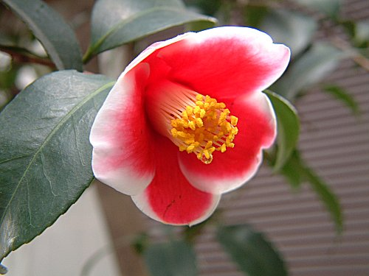

Fig.-1 Japanese camellia.
The name of this Japanese camellia is ‘Tamanoura’.

Table-1 Results of the number and type.
 | Number | Type
 | 5 | A
 | 7 | C
 | 3 | B
 | 11 | B
 | 8 | A
A: white, B: red, C: pink.

(leave one line space)
3. Results

From here, please write the results.
(leave one line space)
4. Discussion

From here, please write the discussions.
(leave one line space)
5. Conclusion

From here, please write the conclusion.
(leave one line space)
References

- M. Higuchi, K. Kitahara, K. Shimizu, K. Hirai, T. Matsumoto, M. Takahashi, J. Soc. Cosmet. Chem. Jpn., 50, 321-328 (2016) (Please list all authors.)
- J.P. Ebanks, A. Koshoffer, R.R. Wickett, S. Schwemberger, G. Babcock, T. Hakozaki, R.E. Boissy, J. Invest. Dermatol., 131, 1226-1233 (2011）
- M. Liebsch, D. Traue, C. Barrabas, H. Spielmann, F. Gerberik, L. Cruse, W. Diembeck, U. Pfannenbecker, J. Spieker, H. G. Holzhütter, P. Brantom, P. Aspin, J. Southee, Prevalidation of the EpiDerm Phototoxicity Test, ed. by D. Clark, S. Lisansky, R. Macmillan, CPL Press, Newbury, 1999, p.160-166
- S. Ota, T. Niimura, R. Azuma, R. Suzuki, K. Kameyama, Proceedings of the 75th SCCJ Research Symposium, 2014, p.8-9
- ISO 25178-2：2012
- U.S.P. 2,345,645 (1990)
- Koyama-kyugu, Kyudo Column. http://www.koyama-kyugu.com/archive/c017.php (accessed 2016.7.25)
- EYJAFJALLAJÖKULL VOLCANO ASH (160 GR.). http://nammi.is/islandische-vulkanasche-aus-dem-eyjafjallajokull-160-gr.html (accessed 2017.4.3)

Attachment
Fig.-1 Japanese camellia.
The name of this Japanese camellia is ‘Tamanoura’.

Table-1 Results of the number and type.
 | Number | Type
 | 5 | A
 | 7 | C
 | 3 | B
 | 11 | B
 | 8 | A
A: white, B: red, C: pink.

Established in January 2024

